Brian Engel

Module 6 Milestone

Interactive data table:

With all:

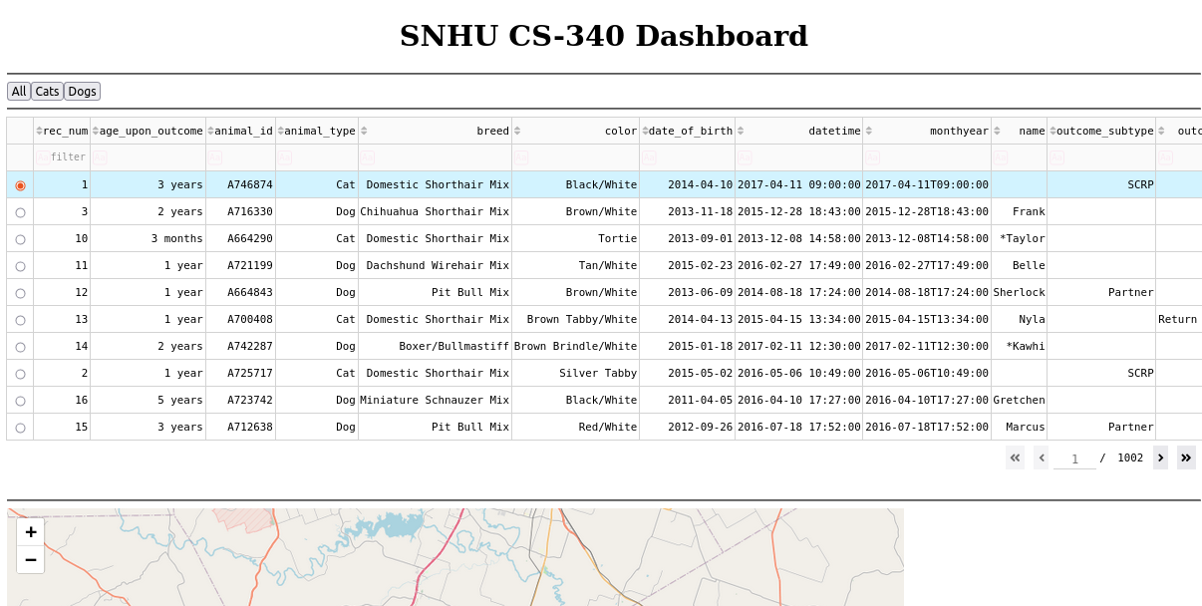

With Cats:

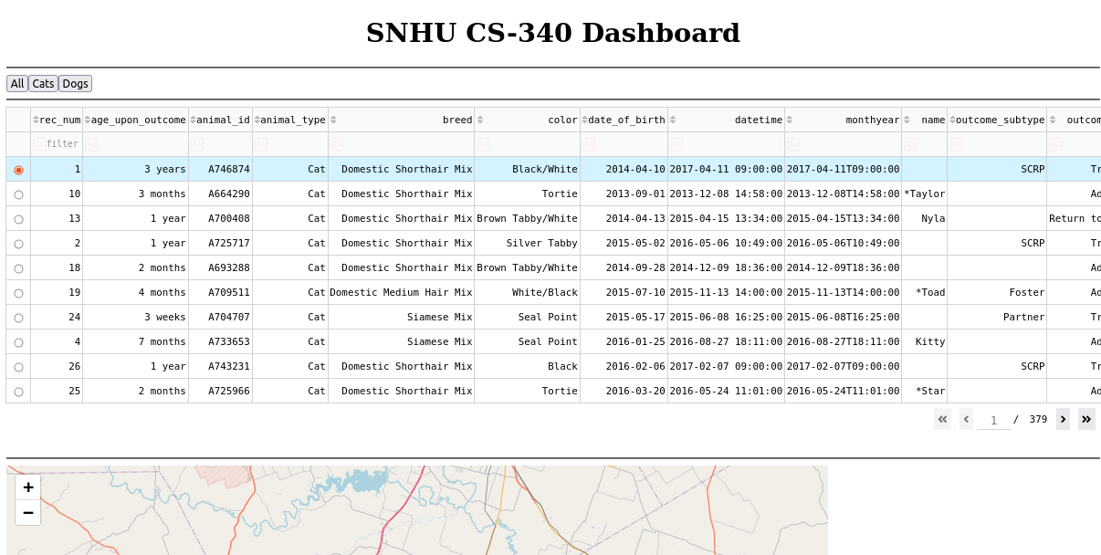

With Dogs:

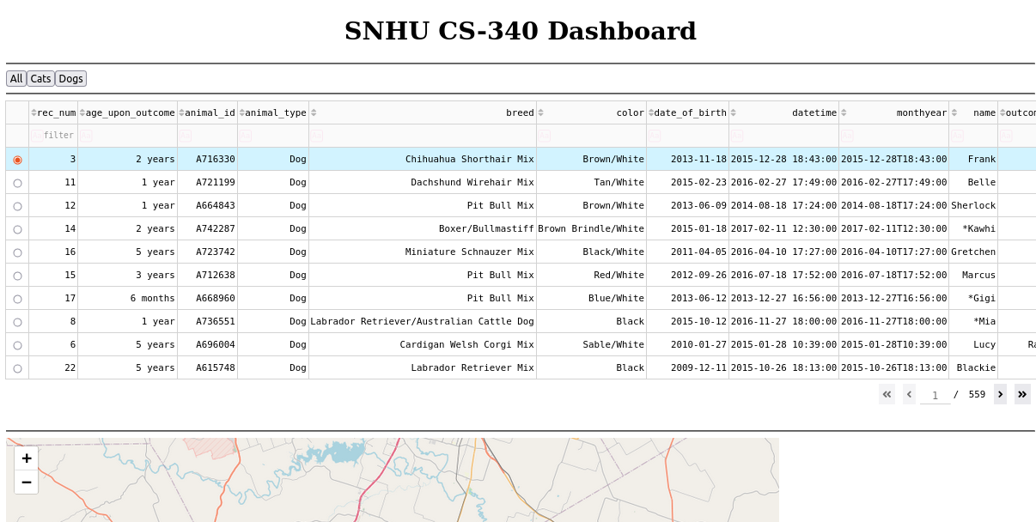

Geolocation chart showing the location of the first dog in the table and unique identifier:

